Task-1

1)Difference between data and information?

|  |  |
| --- | --- |
| **Data** | **Information** |
| 1. Data means raw facts gathered about someone or something which is base and random. | 1. Facts concerning particular event or object which are refined by processing is called information. |
| 2. Data is in forms of numbers, letter and set of characters. | 2. It is ideas and inferences i.e refined data. |
| 3. Data is never designed to the specific need of users. | 3. Information is always specific to the requirements and expectations. |
| 4. data is based on records and observations | 4. Information helps us to do a proper analysis. |
| 5. Data depends on sources of collecting data. | 5. Information is made or gathered based on the data. |
| 6. Data alone has no significance | 6. Information has significance. |
| 7. Data is property of organization and is not available for sale. | 7. Information available for sale to public. |

2)Different types of data?

i) Quantitative data ii) Qualitative data

**Quantitative Data**:- This data Deals with numbers and things and you can represent the measures of any object like length, height, temperature etc.

**Qualitative Data:-** This data deals with the characteristics and descriptors that might not be able to measure but this data can be easily observed.

Quantitative:- a)Discrete Data b) Continuous Data a) Discrete Data:

It is the data which is a whole that it contains only integers.

Eg: Kids, pets, humans etc. b) Continuous Data:

This data can be represented into accurate levels. Eg: time in years, months, days ,hrs ,sec etc.

Qualitative Data:- a) Binomial Data b)Nominal Data c) Ordinal Data

a) Binomial Data: This data is represented as either True/False, Right/Wrong, Good/Bad.

b) Nominal Data: This data provides overview on the basis of category. Category includes color of similar type etc.

c) Ordinal Data: In Ordinal data the data is categorized into an order short, medium, long, tall or basing on the scale.

3)RDBMS handles which type of data?

RDBMS can handle only tabular form of data whether storing or accessing i.e two dimensional data rows and columns.

4) What is Big Data?

• Big Data is a phrase used to mean a massive volume of both structured,unstructured,semi- structured data that is so large,it is difficult to process using traditional database and software.

• 3V’s are

1) Volume

2) Variety

3) Velocity

5) Different Eco systems to handle Big Data.

1. HDFS

2. HBase

3. Sqoop

4. Flume

5. Spark

6. Hadoop Map Reduce

7. Pig

8. Impala

9. Hive

10. Hue

6) Differences between data warehousing and big data.

|  |  |
| --- | --- |
| Data Warehouse | Big Data |
| 1. It is mainly an architecture not a technology. | 1. Big data is mainly a technology which stands on volume , velocity and variety  of data. |
| 2. Accepted one or more homogenous or heterogenous data sources. | 2. Accepts any kind of sources , including business transactions and social media etc. |
| 3. Handles mainly structured data. | 3. Accepts data of all formats. |
| 4. Processing a huge data in data warehouse is really time consuming and sometimes it took an entire day to complete the process. | 4. This is one of the big utility of big data.  HDFS mainly defined to load huge datain distributed systems using map reduce. |

7) Uses of Map Reduce.

1. Map reduce is used to process the data parallel which is present in HDFS.

2. Map reduce is used to split input dat set into independent chunks that are processed in parallel manner.

8)Hadoop is used for?

1. Data exploration with datasets

2. Mining large dataset

3. Large pre-processing of raw data

4. Data agility

9) Hadoop is product of?

• Hadoop is product of apache

10) Hadoop architecture overview

Hadoop follows a Master Slave architecture for the transformation and analysis of large datasets using hadoop Map Reduce paradigm. The 3 components that play vital role in hadoop architecture.

• HDFS

• Hadoop Map Reduce

• YARN

11)Use of Name node, data node, secondary name node and blocks?

**Blocks**: A disk has a variable block size which is minimum amount of data it can read or write

**Name node**: It Is the master and keeps directory tree of all files in the file system and tracks where across the cluster the file data is kept.

**Data node**: It is the slave node. A data node stores data in the hadoop File System.

**Secondary name node**: Its main role is to periodically merge the namespace image with the edit log to prevent edit log from becoming too large.

12) Tools for analyzing the data. Tools are:

1. Tableau Public

2. Open Refine

3. Knime

4. Rapid Miner

5. Google Fusion Tables

6. Nodexl

7. Wolf Ram Alpha

8. Google operations

9. Frontline Solvers

10. Dataiku

13) Uses of Hive.

A Hive is an open system .We can use HIVE for analysis and querying large datasets of Hadoop.

14.Use of Pig.

A. 1.Pig enables data workers to write complex data transformations without knowing Java.

2. Pig can execute its Hadoop jobs in MapReduce, Apache Tez, or Apache Spark.

15. Grid computing vs volunteer computing.

|  |  |
| --- | --- |
| Grid computing | Volunteer computing |
| Grids are a form of distributed computing whereby a “super virtual computer” is composed of many networked loosely coupled  computer acting together to perfrom large tasks. | **Volunteer computing** is a type of distributed computing , "an arrangement in which people, so-called volunteers, provide computing  resources to projects, which use the resources to do distributed computing and/or storage". |
| Grid computing combines computers from multiple administrative domains to reach a common goal, to solve a single task, and may then disappear just as quickly. | Volunteer computing can provide researchers with computing power that is not achievable any other way. Approximately 10 petabytes of computing power are available from volunteer computing networks. |

Task-2

To perform various queries in SQL

Creating database:

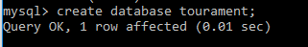

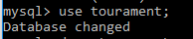

Creating a table:



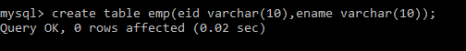

Inserting values into table:



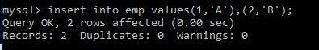

Displaying data:

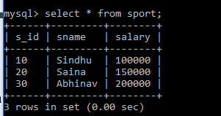

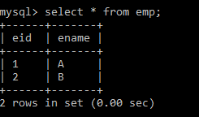

Dropping a table:

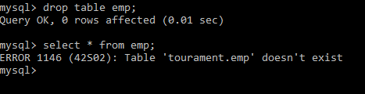

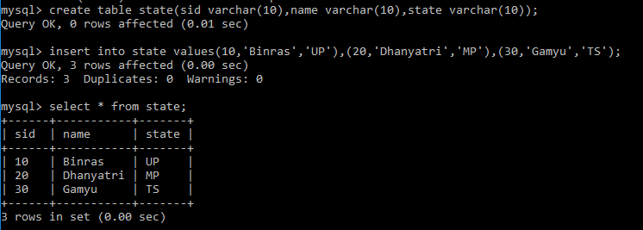

Cross join:

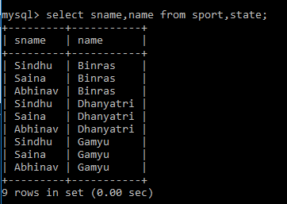

Inner join:

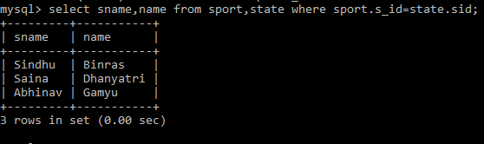

Left join

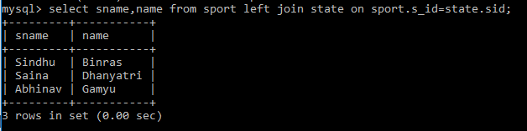

Right join:

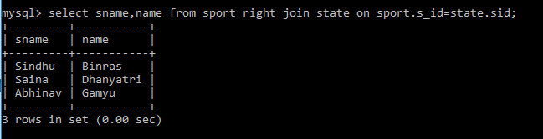

Full join:

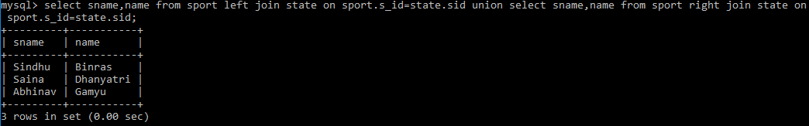

Sub-Queries

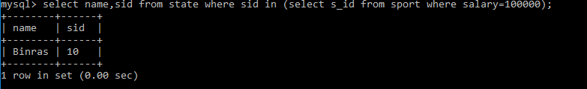

All:



**Task-3**

**Aim**: Installation of Cloud era.

**Step-1**: Open C drive and click on cloudera-quickstart-vm-4.7.0-0-virtual box.

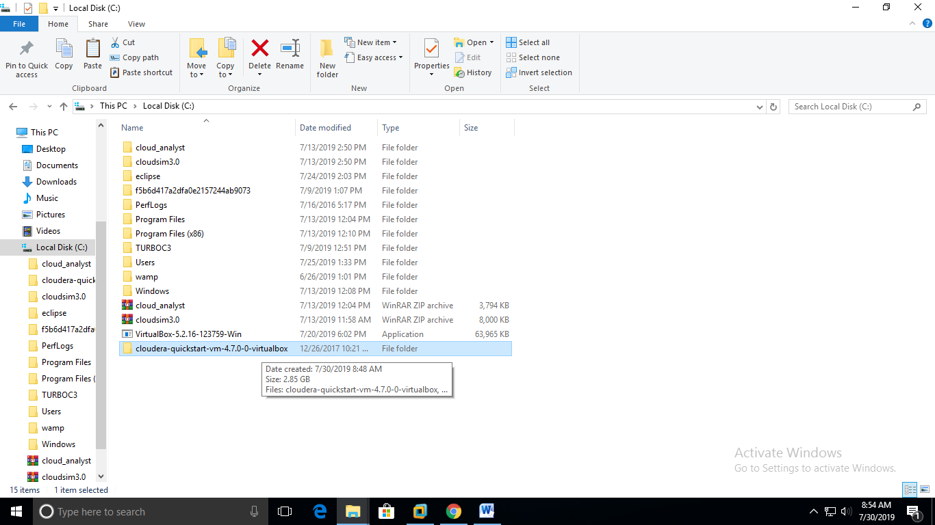

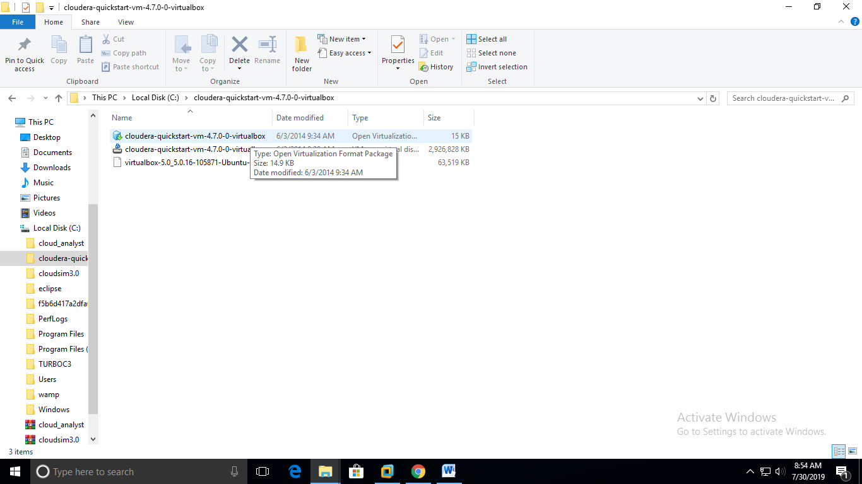

**Step-2**: Then display a dialog box then select VMware Workstation and click OK.

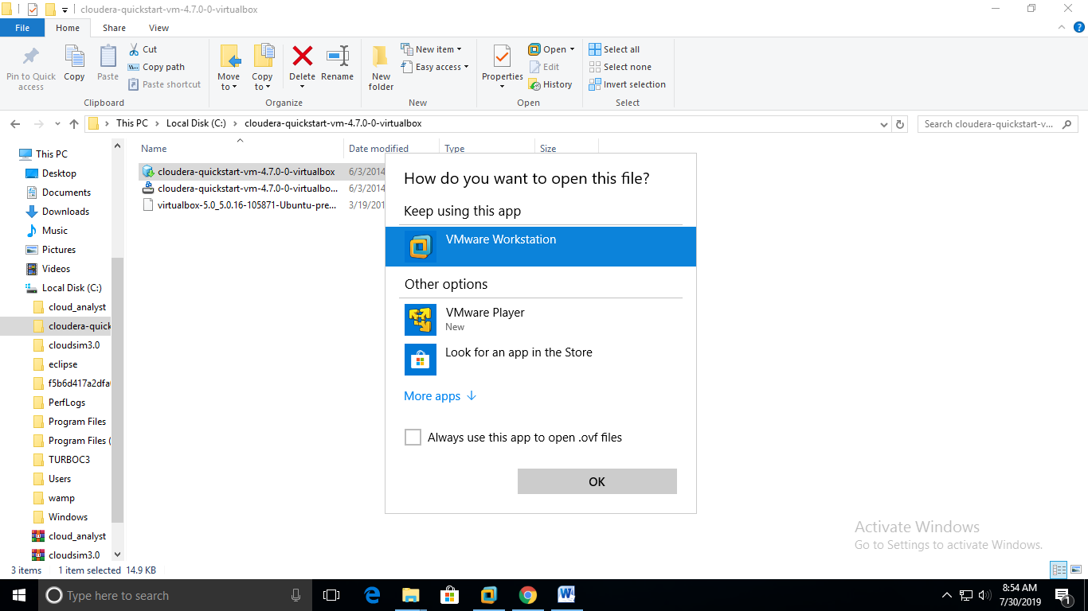

**Step-3**: Then displays dialog box select import and click OK.

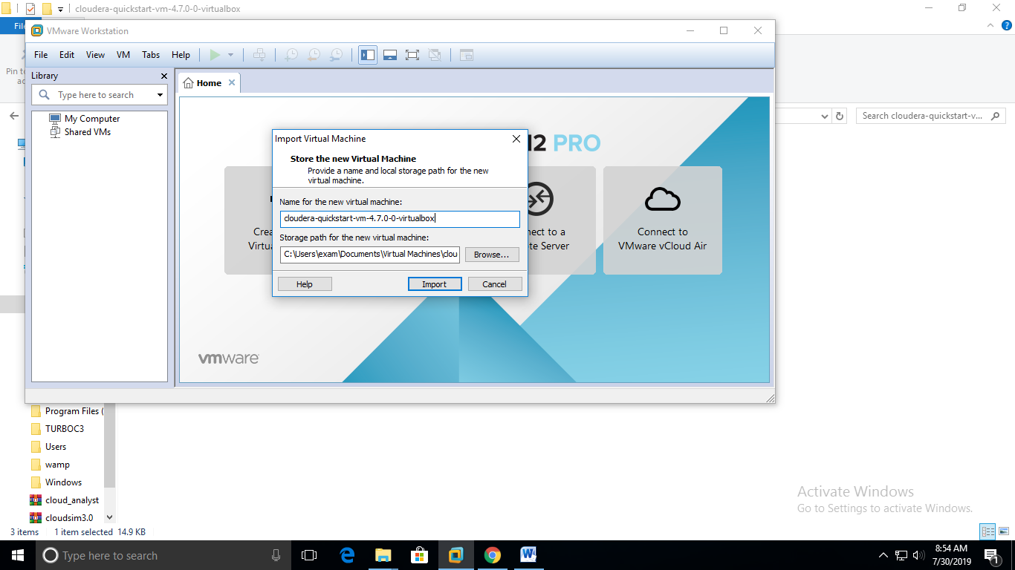

**Step-4**: Then select Power to cloud eraon the left panel of the VMware Application.

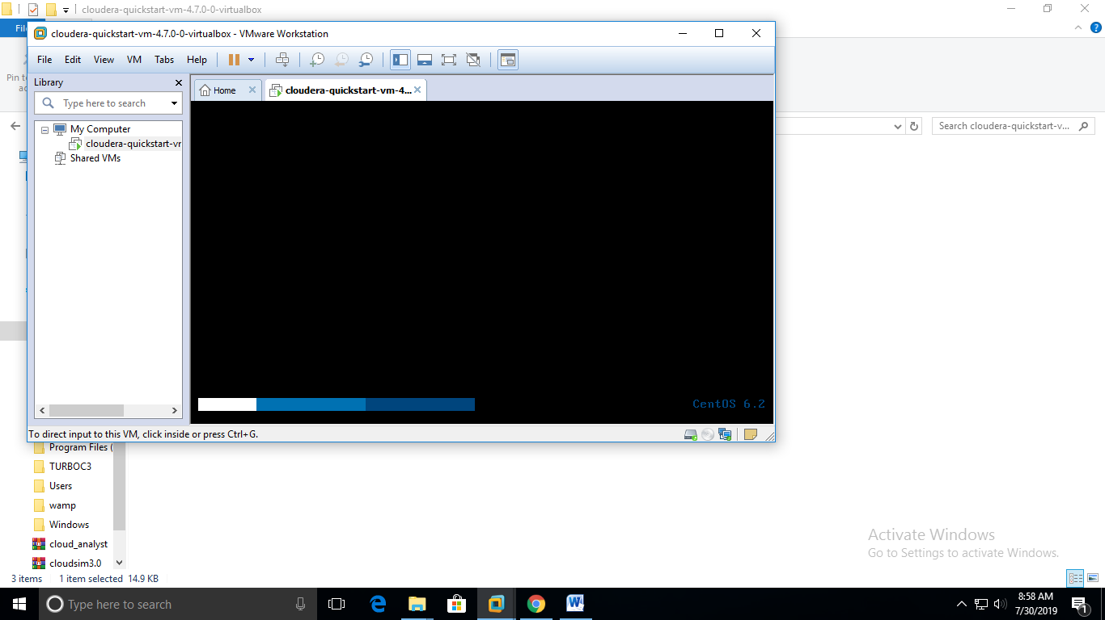

**Step-5**: Now Virtual machine display as it follows.

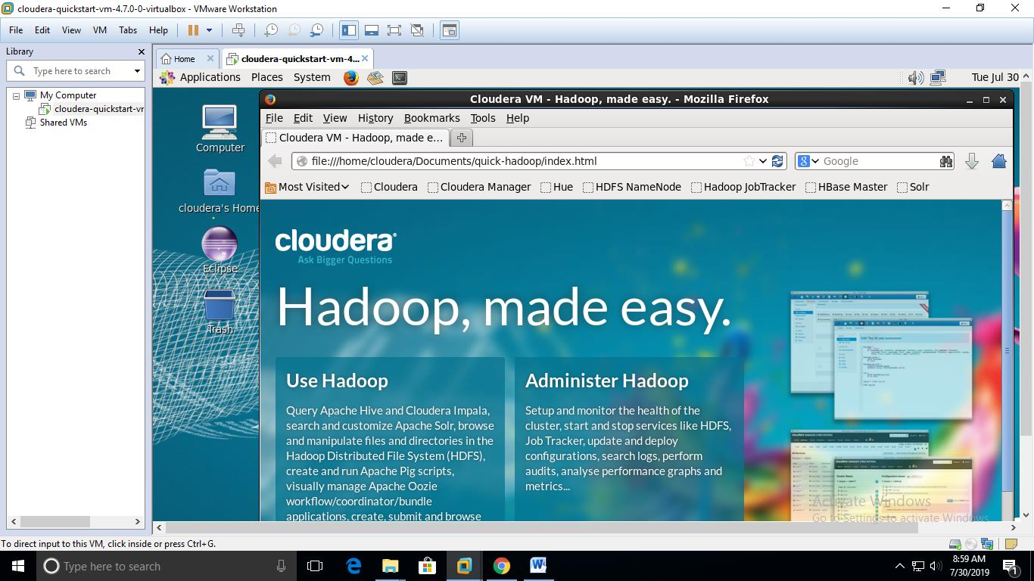

**Result**: Installation of cloudera has been successfully described here.

Task- 4

**Aim**: Exploring HDFS (Hadoop Distributed file system) file system. Listings of files, exploring directories

**Step1**: Open Virtual box tool and click on start services, it displays cloudera homepage

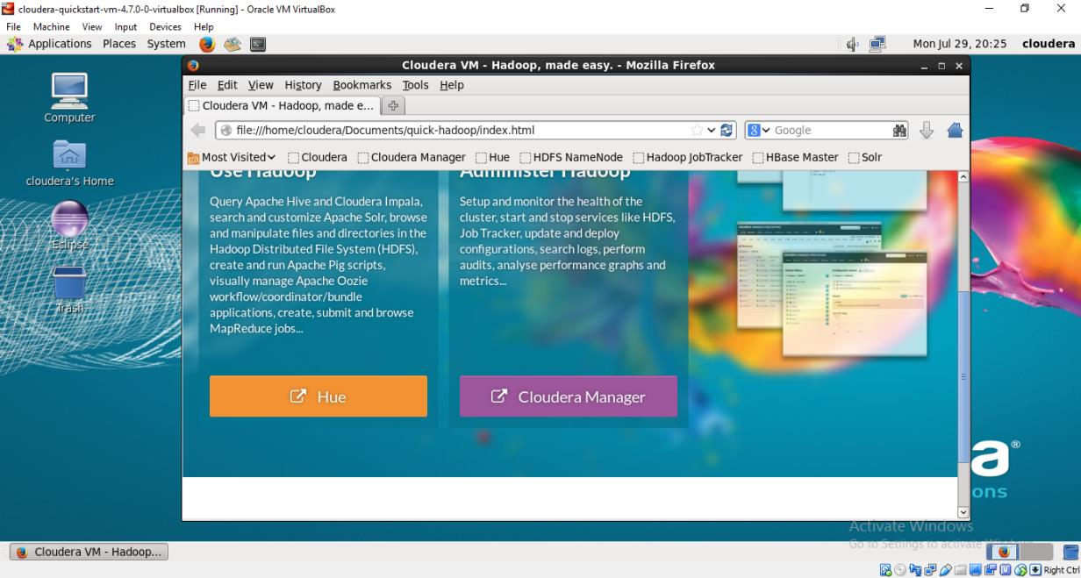

**Step2**: Run Mozilla firefox browser to open index file.html page. Then click on cloudera manager, cloudera services page will be displayed.

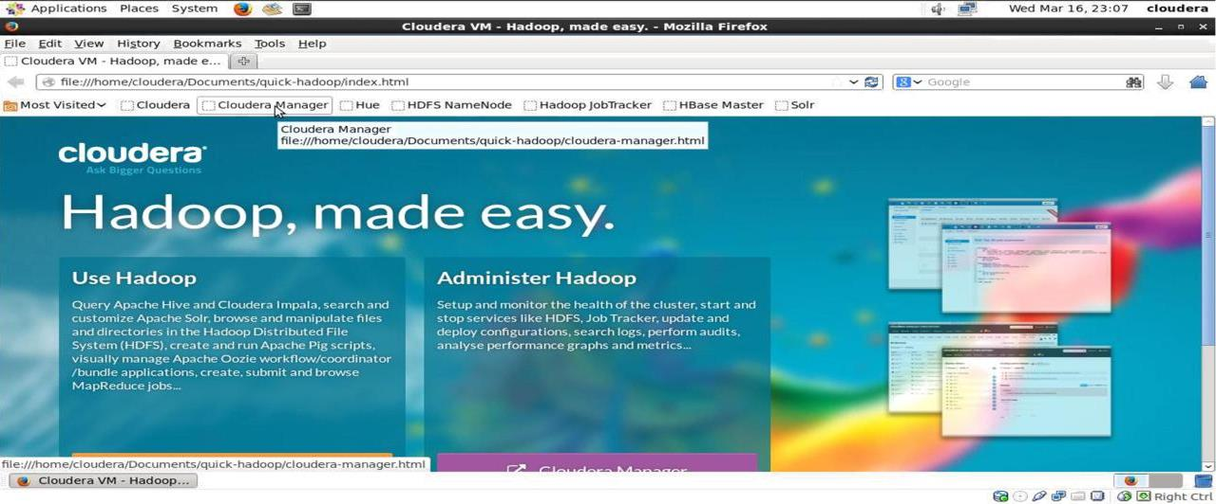

**Step3**: After selecting cloudera Manager, Provide Authentication Details Username :

Cloudera and password: cloudera

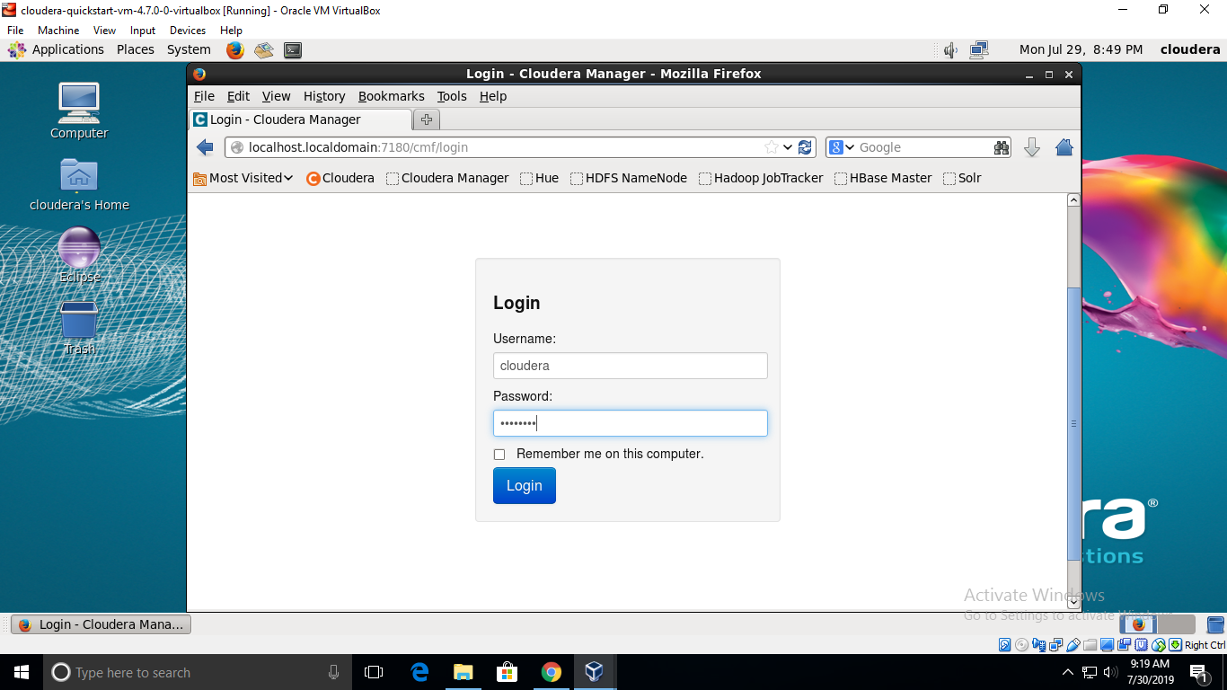

**Step4**: Services will be displayed.

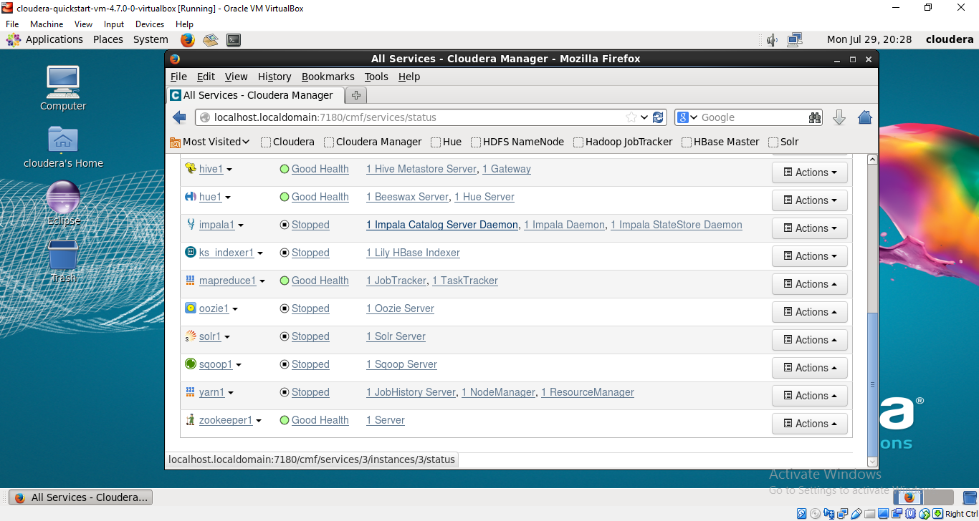

**Step5**: check the health status of ‘hdfs’ and ‘zookeeper’ and Click on action and start the

Services

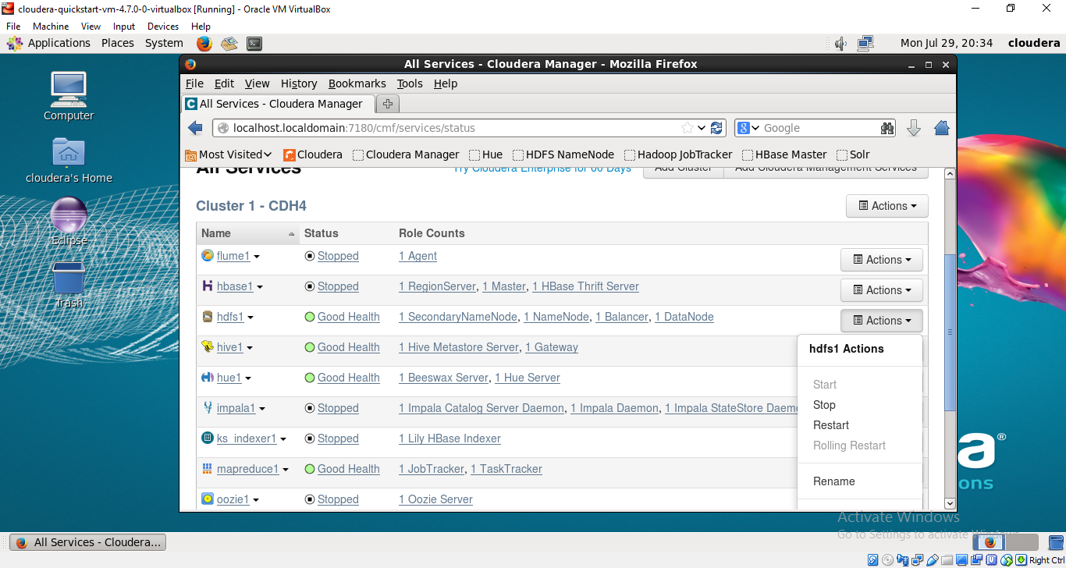

**Step6**: Click on Applications->systemtools->Terminal

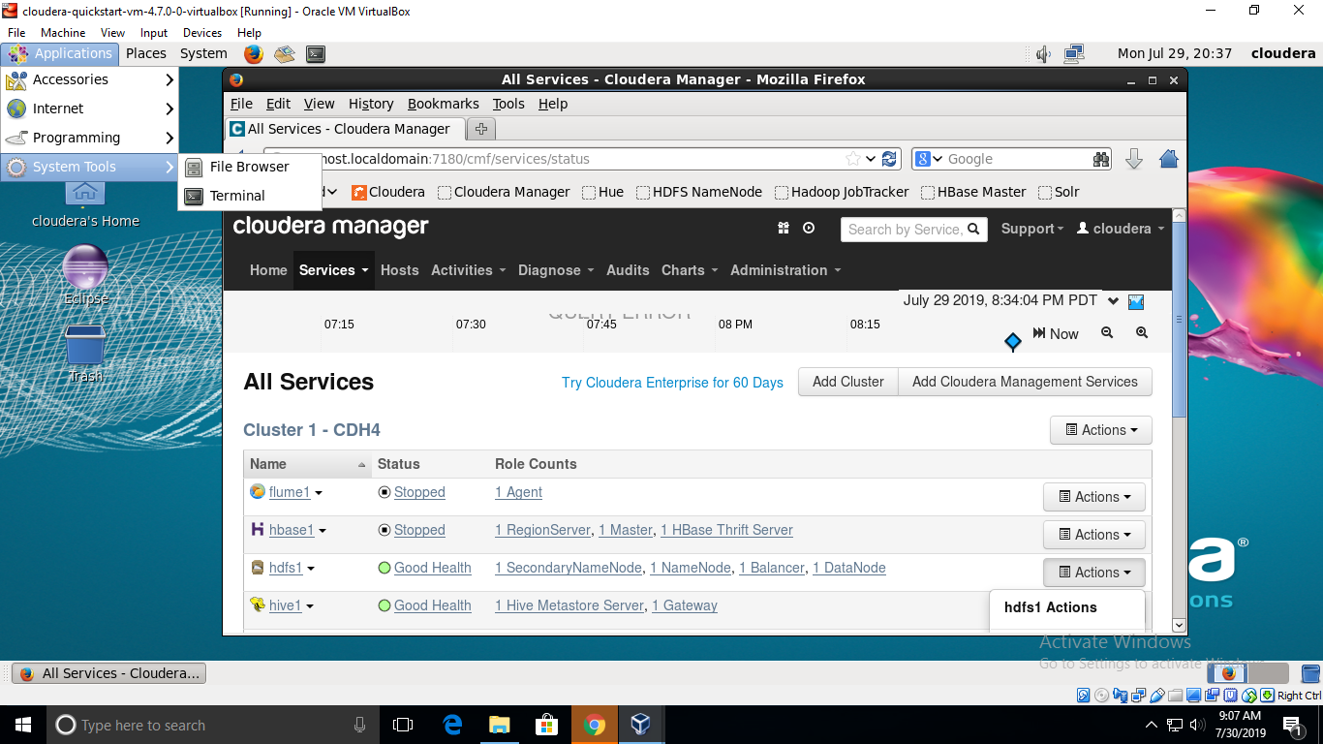

**Step7**: Commands performed in linux terminal

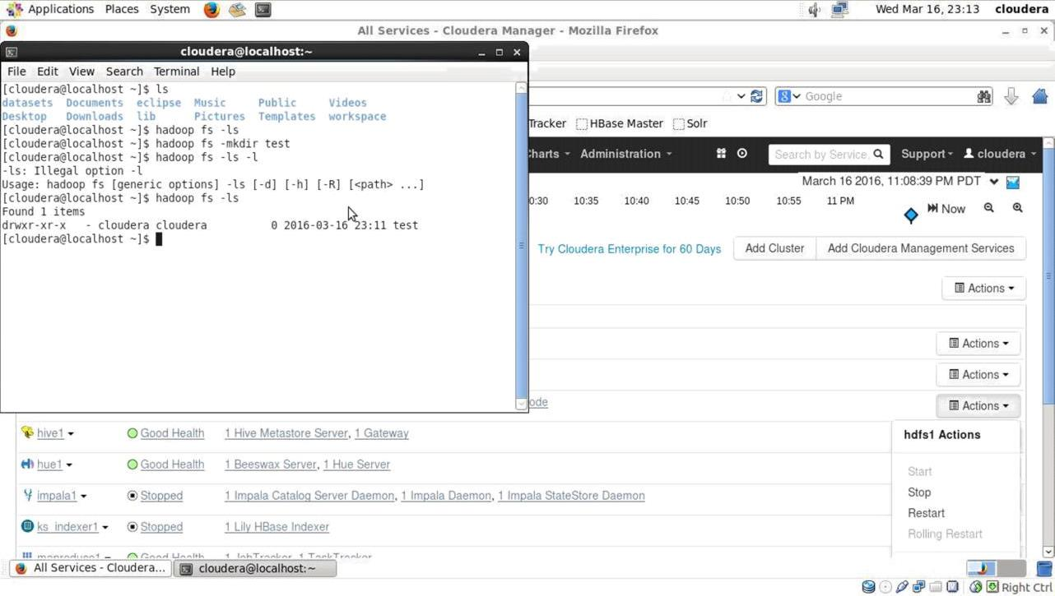

**Result**: Exploring HDFS (Hadoop distributed file system) file system. Listing of files, exploring directories has been done successfully.

**TASK-5**

1. To copy files from local file system to Hadoop file system. Create file on local system(linux). (Ex. Desktop/sample.txt)

Open terminal and type

Hadoop fs –copyFromLocal Desktop/sample.txt test

Hadoop fs –ls test

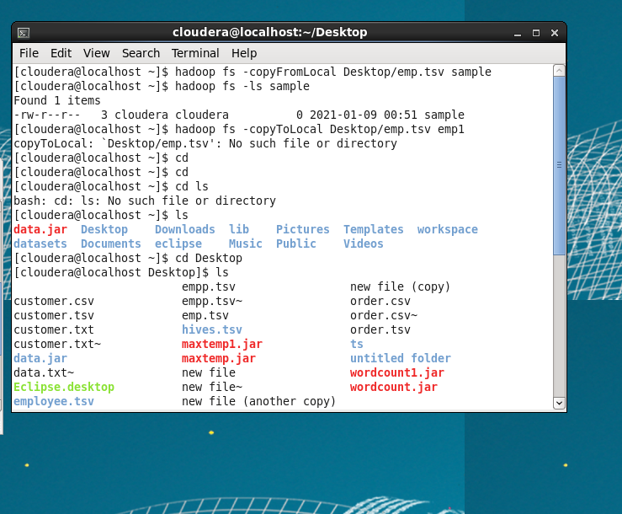

1. Hadoop commands to copy to Local from hdfs

In the terminal type as following

hadoop fs -copyToLocaldirectory_name/existing_file_namenew_file_name

Now check the files in desktop using ls The commands are as shown below

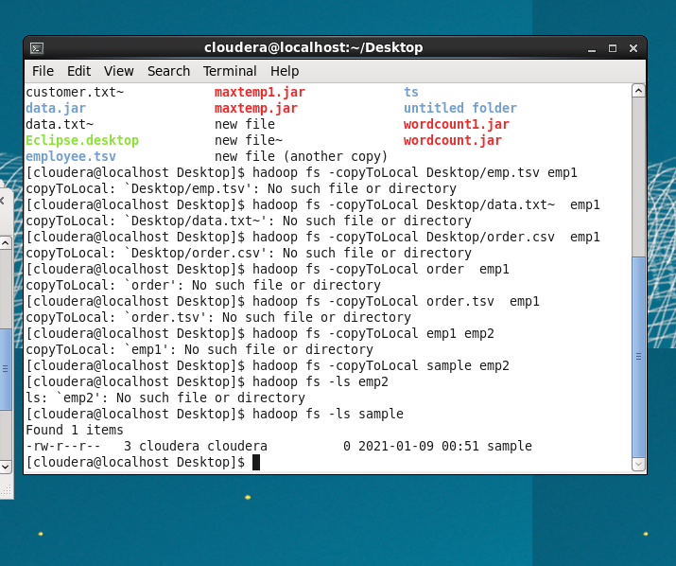

1. To see the files in the hadoop file system open the mozila fire fox and open Hdfs name node as shown below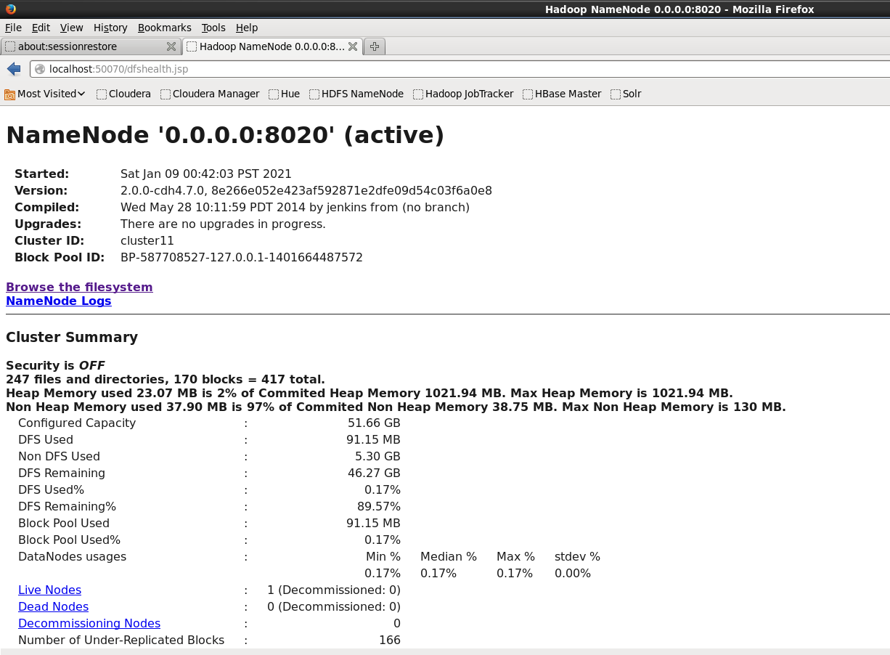

**4.** Click on browse file system and see the Files

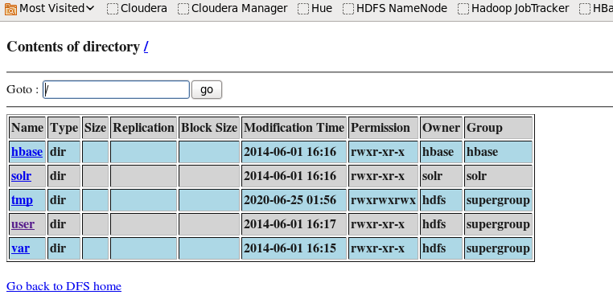

Result: The Hadoop operations using commands are performed**.**

Task-6

To create the table and get its contents

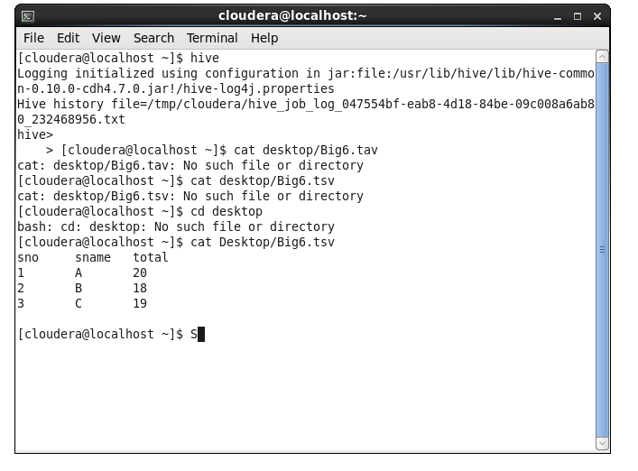

Creating table in hive:

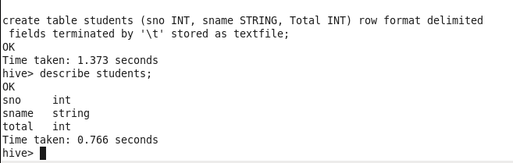

Altering a table name:

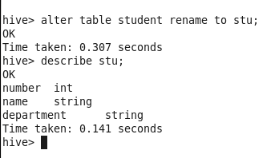

**TASK-7**

AIM: Loading data into hive warehouse and perform aggregate operations

Steps:

Create tsv file with numeric data

Open terminal and enter hive

And enter commands as shown below

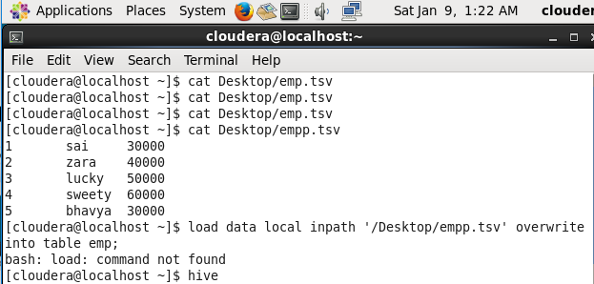

Load file into the table

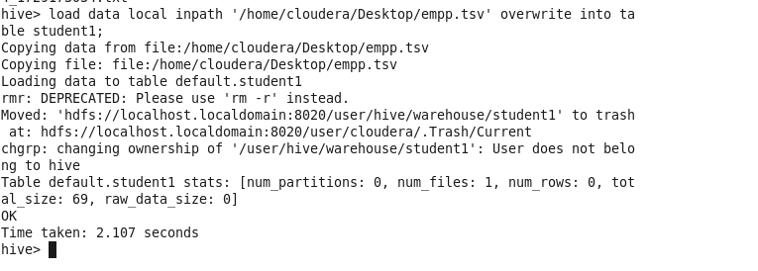

Aggregate operators

Maximum:

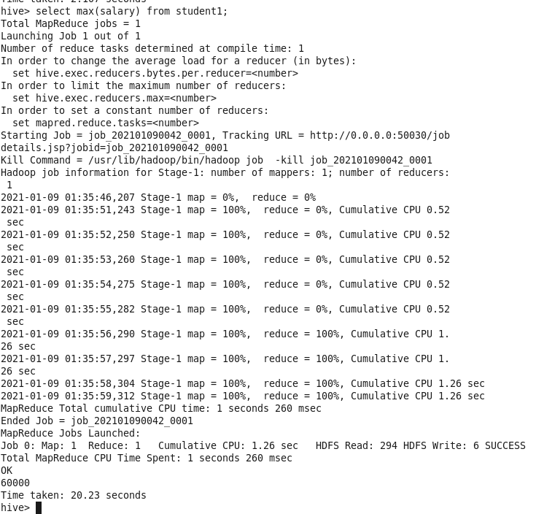

Count:

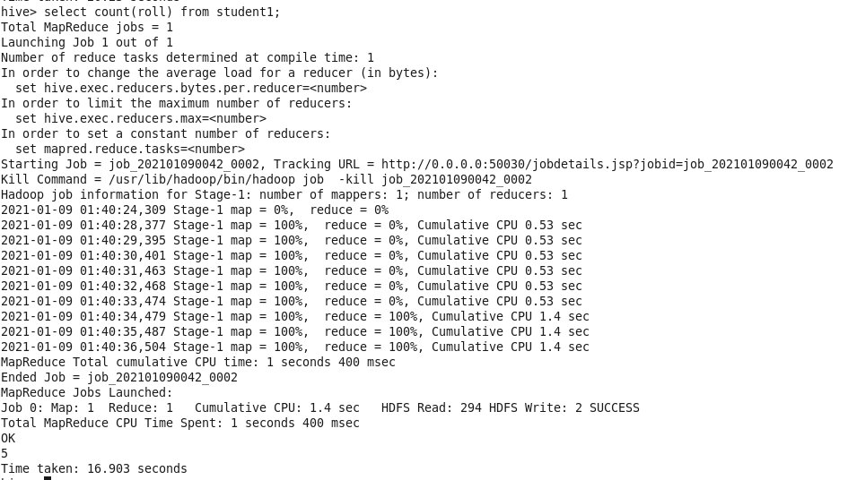

Result: Loading of data into hive tables and performing operations on it hasbeen successfully explained.

**TASK-8**

AIM: Finding wordcount job in hadoop executing map reduce code

Steps:

1. Start eclipse create new java project and enter a name for the project

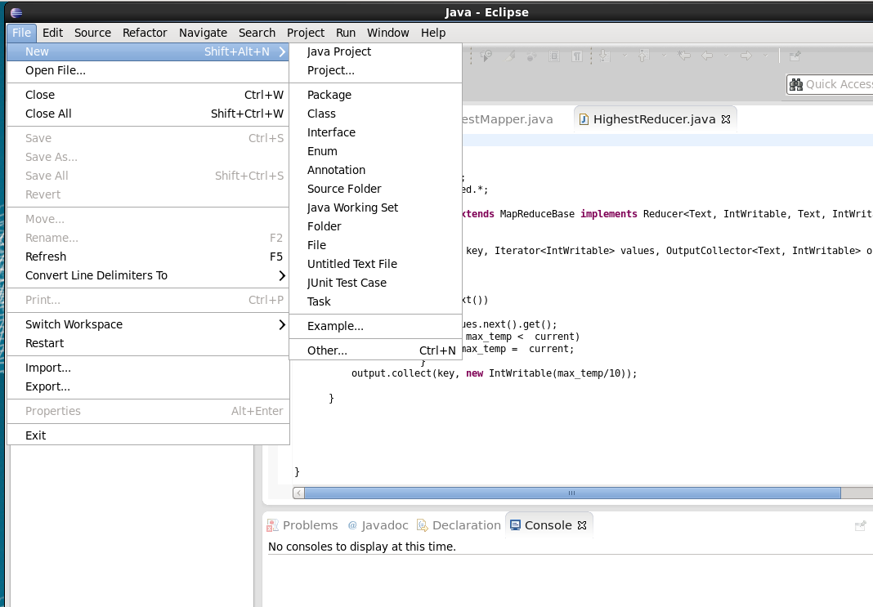

2. Copy the file form local system and copy near the src of the project created

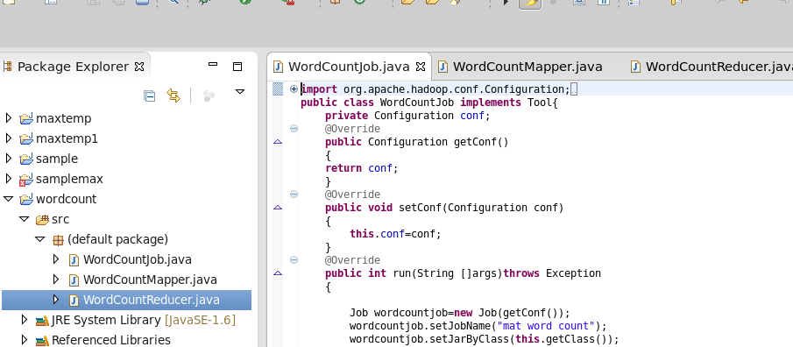

3. Click on project, properties and click build path to add external jars

The external jars:

1. Usr/lib/Hadoop/Hadoop-common.jar

2. Usr/lib/Hadoop/ client-0.20/ (all jars)

3. Usr/lib/Hadoop/lib/commons-code-1.4.jar

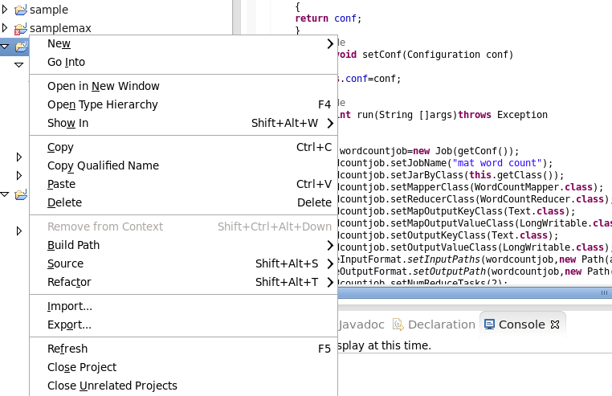

4. Export the project to the desktop

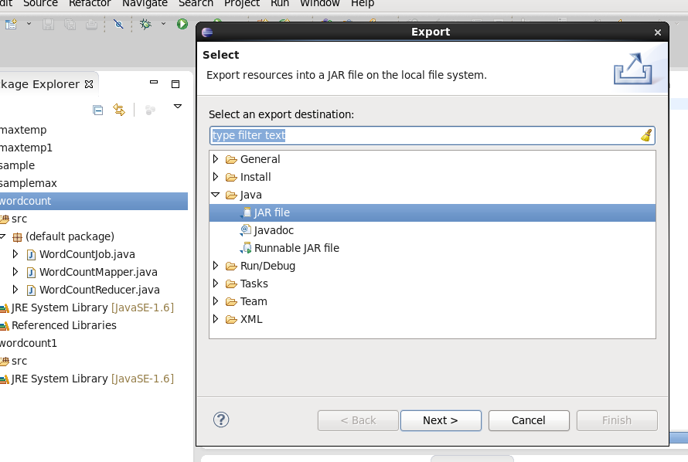 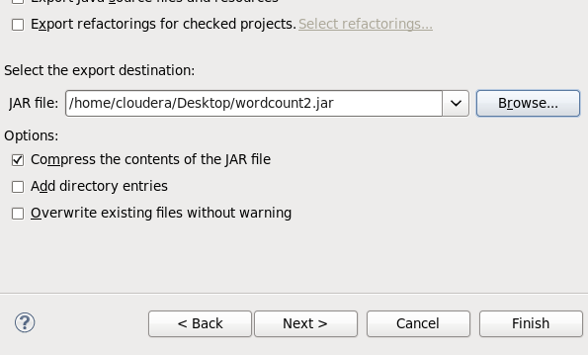

5. Store test file in hdfs by opening the terminal from the test files and run wordcount.jar on that file by using following command

Hadoop jar wordcount.jar [mainclassfilename] [input hdfs path] [output hdfs

folder]

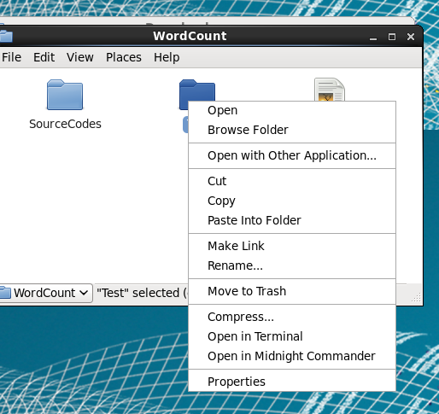

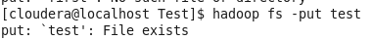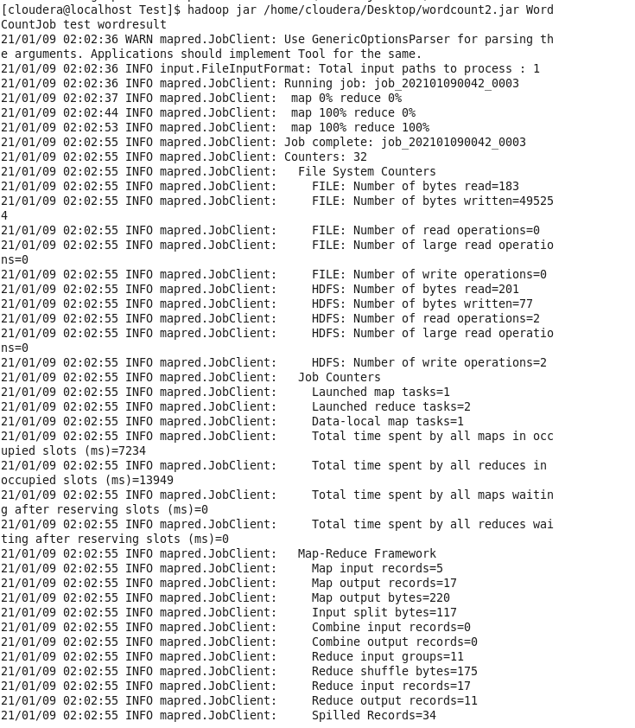

6. Check the result in the HDFS namenode

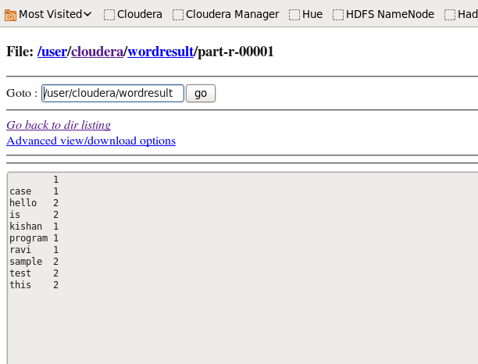

Result: WordCount Job is executed

**TASK-9**

AIM: Finding wordcount job in hadoop executing map reduce code

Steps:

1. Start eclipse create new java project and enter a name for the project

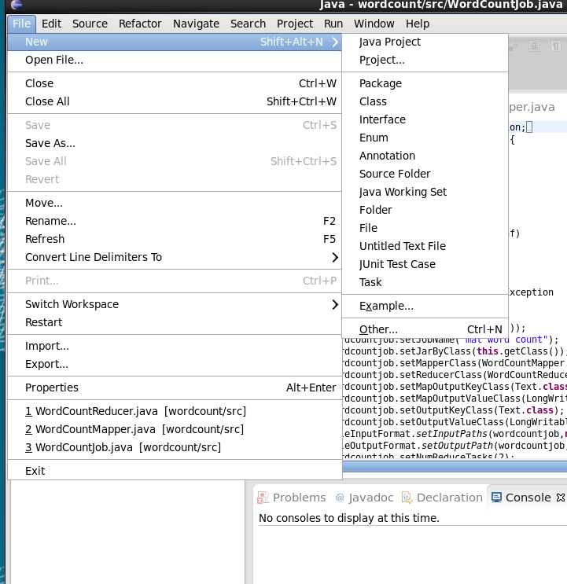

2. Copy the file form local system and copy near the src of the project created

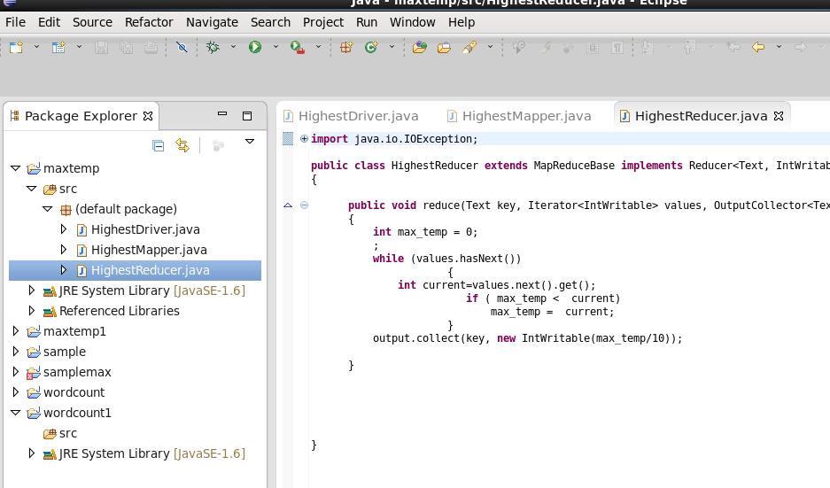

3. Click on project, properties and click build path to add external jars

The external jars:

1. Usr/lib/Hadoop/Hadoop-common.jar

2. Usr/lib/Hadoop/ client-0.20/ (all jars)

3. Usr/lib/Hadoop/lib/commons-code-1.4.jar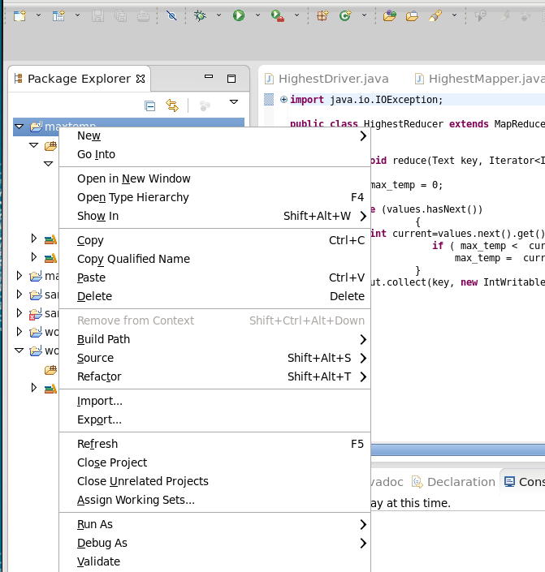

4. Export the project to the desktop





5. Store test file in hdfs by opening the terminal from the test files and run wordcount.jar on that file by using following command

Hadoop jar wordcount.jar [mainclassfilename] [input hdfs path] [output hdfs

folder]

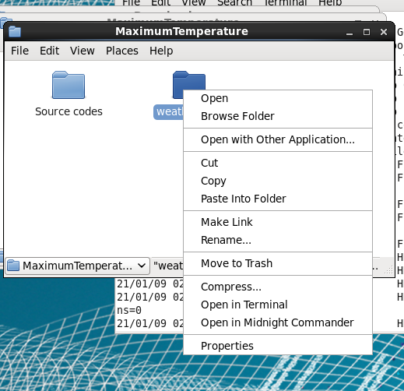

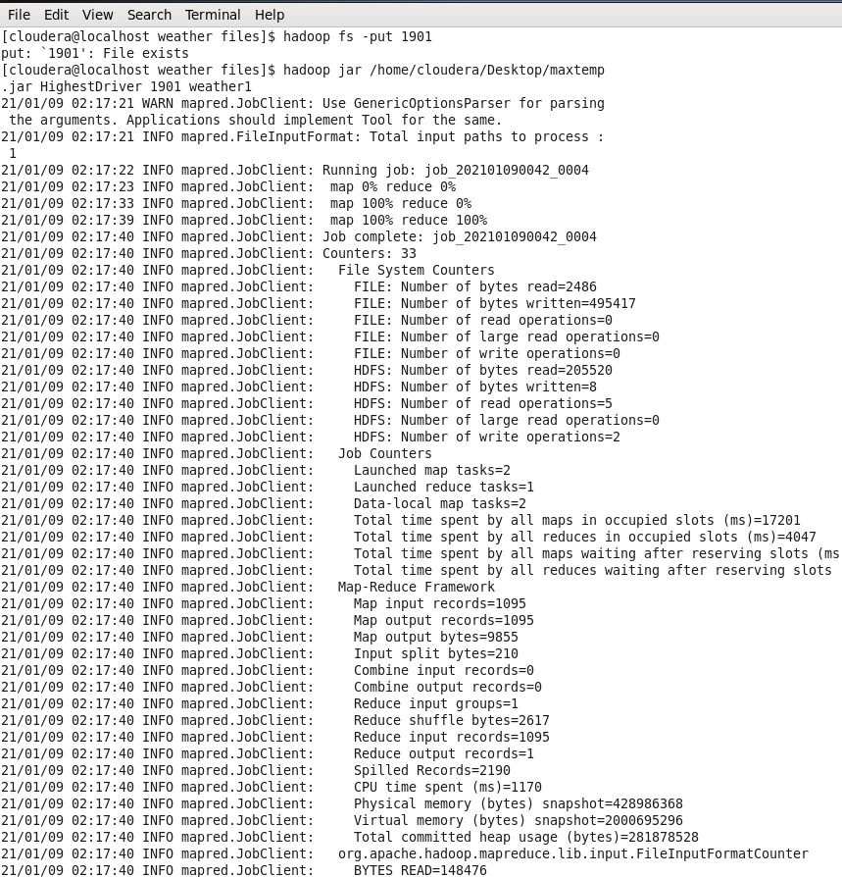

6. Check the result in the HDFS namenode

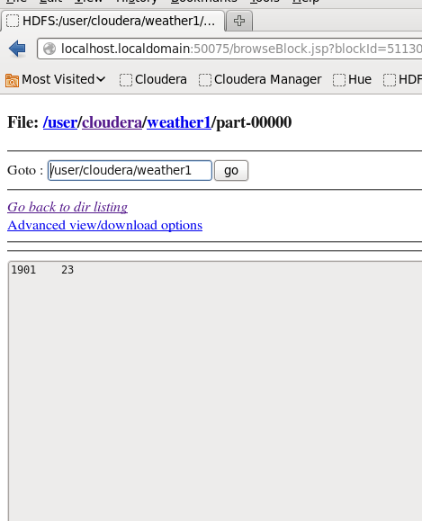

Result: Max temp is executed